

**Tribhuvan University**

**Faculty of Humanities and Social Sciences**

**A PROJECT REPORT**

**Food Ordering System**

**Submitted to:**

**Lumbini City College**

**Department of Computer Application**

**Tilottama - 4, Rupandehi**

***In the partial fulfillment of the requirement for the Bachelor of Computer Application***

**Submitted by:**

Suman Khatri (T.U.Reg.No:-6-2-1134-60-2020)

Chitra Bahadur Thapa (T.U.Reg.No:-6-2-1134-42-2020)

07-03-2023

**Under the Supervision of**

Mr. Suraj Khatri

**Acknowledgement**

We would like to express our sincere gratitude to Lumbini City College for providing us with the platform to explore our interests and ideas in software development through this project. Our heartfelt thanks go to Mr. Bishal Kandel, our Academic Coordinator, for his invaluable advice and guidance in selecting our project topic and providing us with the necessary resources. We would also like to extend our appreciation to our supervisor, Mr. Suraj Khatri, for his unwavering support, supervision, and valuable insights throughout the project. Additionally, we are grateful to our friends, classmates, and all those who have provided us with guidance and assistance along the way. Their contributions have been instrumental in the successful completion of this project.

TABLE OF CONTENTS

Chapter 1: Introduction 1

1.1 Introduction 1

1.2 Problem Statement 1

1.3 Objective 2

1.4 Scope and Limitations 2

1.5 Report Organization 3

Chapter 2: Background Study and Literature Review 4

2.1 Background Study 4

2.2 Literature Review 4

3.1 Research Methodology 6

3.2 System Analysis 6

3.2.1 Requirement Analysis 6

3.2.1.1 Functional Requirements: 6

3.2.1.2 Non-functional Requirements: 7

3.2.2 Feasibility Study 8

3.2.3 Analysis 8

3.3 System Modelling 9

3.3.1 Data Modelling: ER-Diagram 9

3.3.2 Use–case Diagram 10

3.3.3 Process Modelling: Data Flow Diagram (DFD) 11

3.3.4 Gantt Chart 14

Chapter 4: System Design 15

4.1 System Design 15

5.1 Appendices 16

5.1.1 Screenshots 16

Chapter 6: References 22

# **Chapter 1: Introduction**

## Introduction

This project has been submitted in the fulfilment of the requirements for the Bachelor of Computer Application. We the team members of this project, take pleasure in presenting the detail project report that reflects our efforts in this semester.

Our project name is Food Ordering System. This system aims to provide an easy and convenient way for customers to order food online from different restaurants. With the increasing trend of online food ordering, this system will be a useful tool for customers to order food in a hassle-free way. The system will provide a user-friendly interface that will enable customers to place their orders quickly and easily.

The Food Ordering System will consist of a user-friendly interface that allows customers to browse menus, select items, and place their order with just a few clicks. The system will also allow restaurant owners to manage their menu from a centralized platform.

With the increasing trend of online food ordering, there is a need for a system that provides customers with an easy and convenient way to order food online. The Food Ordering System aims to fulfil this need by providing a platform for customers to order food online.

## 1.2 Problem Statement

The traditional method of ordering food in person or over the phone has become increasingly inconvenient and time-consuming for customers. Additionally, restaurant owners are struggling to manage orders and ensure efficient delivery of food items. These issues have led to a need for a more streamlined food ordering system that can simplify the process of ordering food for both customers and restaurant owners. The current systems often lack a user-friendly interface, efficient order management, and accurate order tracking, resulting in delays, errors, and dissatisfied customers. Therefore, there is a need for a reliable and efficient food ordering system that can improve the customer experience and enhance the overall efficiency of the food ordering process.

## 

## 1.3 Objective

We have made the Food Ordering System to simplify the process of ordering food online. Some of the specific objectives of this system are listed below:

1. To provide customers with a fast and convenient method of ordering food.
2. To improve accuracy in the order taking process.
3. To streamline the delivery process.
4. To provide customers with a user-friendly and intuitive ordering interface.
5. To enable restaurant owners to manage orders.

## 1.4 Scope and Limitations

## Scope:

The scope of the food ordering system includes providing customers with a wide range of options, including both vegetarian and non-vegetarian dishes. The system will have a menu and item management module to add, remove, and update traditional Nepali food items on the menu. The ordering process will be simplified, and real-time updates will be provided on the status of orders. The system will be user-friendly and secure, ensuring the privacy and security of customer data. Overall, the food ordering system will provide a seamless and convenient experience for customers, allowing them to easily browse through the menu, select their desired items, and place orders from the comfort of their homes or workplaces.

### Limitations:

The limitations of this project are given below:-

1. Delivery limitations: Online food ordering systems are dependent on third-party delivery services, which may have limitations on delivery range, delivery times, and delivery fees. This can impact the convenience and overall experience of the customer.
2. No Order tracking: It is very complex process to order track so we will not use order tracking.

## 

## 1.5 Report Organization

* Chapter One **Introduction** includes the problem statement, objectives, scope and limitation, and development methodology of this project.
* Chapter Two **Organization Details and Literature Review** includes a background study and Literature Review of this project.
* Chapter Three **System Analysis** consists of Requirement Analysis, Feasibility Analysis, and Structured or Object-Oriented Analysis used in the system which will be developed.
* Chapter Four **Implementation and Testing** includes topics like Implementation, Testing, and Result Analysis of this project.
* Chapter Five **Conclusion and Future Recommendation** includes the conclusion of the system and future recommendations from the project developed.

# **Chapter 2: Background Study and Literature Review**

## 2.1 Background Study

A food ordering system is a digital platform that allows customers to place orders for food delivery or pickup from restaurants or food establishments. To develop an effective food ordering system, a background study should be conducted to consider various aspects, including market research, user requirements, technical requirements, user experience, security and privacy, and maintenance and support. Market research helps to identify the target audience, competition, and current trends in the food industry, which helps to determine the unique features and functionalities that the system should offer. User requirements should also be considered, including payment options, delivery preferences, and order tracking. Technical requir–ements should be identified, such as the hardware, software, and database requirements, as well as necessary integrations with other systems, like payment gateways and delivery services. The user experience will be designed to provide a user-friendly interface that allows customers to navigate the platform easily and complete their orders efficiently. The system's security and privacy are essential to protect customer data and payment information. Finally, establishing a plan for maintenance and support is critical to ensuring ongoing system operation and customer satisfaction. By considering these factors, businesses can create an effective and robust food ordering system that meets customer needs while improving operational efficiency.

## 2.2 Literature Review

The use of online food ordering systems has become increasingly popular in recent years, with more and more consumers opting for the convenience and ease of ordering food online. According to a report by Statista (2021), the global revenue of the online food ordering industry is projected to reach $151.5 billion by 2024, up from $72.9 billion in 2020. This highlights the significant growth potential of the industry and the increasing demand for online food ordering systems.

Studies have shown that online food ordering systems can improve customer satisfaction and loyalty (Wang & Tsai, 2017). Customers appreciate the convenience of being able to order food from anywhere, at any time, without having to wait in long queues or make phone calls. This is particularly true for younger generations who are accustomed to using technology in their daily lives (Mishra & Sharma, 2017).

Moreover, online food ordering systems can also help restaurants to increase their sales and revenue by offering customers an easy and user-friendly way to place orders (Wang & Tsai, 2017). This is particularly relevant during the COVID-19 pandemic, where many customers are opting for delivery and takeaway options over in-person dining.

However, online food ordering systems also have their limitations. Technical issues, such as software bugs or server downtimes, can impact the overall performance of the system (Batra, 2020). Additionally, the implementation and maintenance costs of an online food ordering system can be relatively high, making it challenging for small businesses to adopt (Mishra & Sharma, 2017).

In conclusion, online food ordering systems offer significant benefits for both customers and restaurants, including convenience, increased sales, and improved customer satisfaction.

**Chapter 3: System Analysis**

## 3.1 Research Methodology

For the development of an online food ordering system, the research methodology would follow the waterfall model. This would start with the requirements gathering phase, where stakeholders would define all the requirements for the system, including features, functionality, and performance. Once the requirements are gathered, the design phase would begin, where the system architecture, database design, and user interface would be designed. The implementation phase would then start, where the development team would begin writing code and implementing the features and functionality based on the design. After implementation, the system would undergo testing to ensure that it meets all requirements and functions as intended. Once testing is complete, the system would be deployed to a production environment for use by end-users. Finally, ongoing maintenance and support would be required to ensure the system continues to function as intended.

## 3.2 System Analysis

### 3.2.1 Requirement Analysis

System analysis is the process by which a person or people study a system to assess, model, and select a logical alternative for an information system. Three factors—problems, opportunities, and directives—are the driving forces behind the start of systems analysis initiatives. Furthermore, systems analysis provides a structured approach to decision-making, ensuring that all relevant factors are considered before making changes to an information system. This helps to minimize risks and ensure that the system changes are aligned with the organization's goals and objectives.

**3.2.1.1 Functional Requirements:**

1. User registration and authentication: Users will be able to create an account, log in, and manage their profile information.
2. Ordering process: The system should provide a user-friendly interface for customers to browse menu items, add them to their cart, and specify any special instructions or preferences. The system should also handle payments securely.
3. Restaurant management: Restaurants will be able to view and manage their orders and update their menu.
4. Customer support: The system will provide customer support features such as FAQs, chat support, and email support.

### 3.2.1.2 Non-functional Requirements:

1. Performance: The system will be designed to handle high traffic and load without significant downtime or slowdowns.
2. Security: The system will use encryption and other security measures to protect user data, payment information, and other sensitive information.
3. Reliability: The system will be reliable and available 24/7, with minimal downtime for maintenance or upgrades.
4. Usability: The system will be user-friendly and easy to navigate, with clear instructions and feedback for users.
5. Compatibility: The system will be compatible with a variety of devices and platforms, including desktop and mobile devices, various operating systems, and different web browsers.
6. Accessibility: The system should be designed to be accessible to users with disabilities, including support for assistive technologies like screen readers and keyboard navigation.
7. Scalability: The system should be scalable, able to handle increasing amounts of data and traffic as the business grows.
8. Maintainability: The system should be easy to maintain and update, with a modular design and clear documentation for developers.

### 3.2.2 Feasibility Study

A feasibility study is an analysis of the potential for a project to be successful. It is used to determine whether the project is worth pursuing and to identify any potential challenges or obstacles that may need to be addressed. A feasibility study typically includes an assessment of different feasibility. It studies economic, legal, and operational feasibility. Economic feasibility evaluates the financial viability of the project, including the costs and benefits of implementing the system. Legal feasibility assesses whether the project complies with relevant laws and regulations, such as data privacy laws. Operational feasibility examines whether the project can be integrated with existing systems and processes and whether it can be effectively used by the intended users. By conducting a thorough feasibility study, it is possible to identify any potential barriers to the success of the project and to develop strategies to address them. This can help to minimize risks and ensure that the project is successful in meeting the needs of the stakeholders.

**Technical feasibility:** This system is technically feasible to implement. The technical feasibility of the proposed system will be evaluated by considering the hardware and software requirements, internet connectivity, and any technical barriers that could affect the system's performance.

**Economic feasibility:** This system is economically feasible to implement. The economic feasibility of the proposed system will be evaluated by considering the costs involved in implementing and maintaining the system. This will include hardware and software costs, website design and development costs, and ongoing maintenance and support costs.

**Operational feasibility:** The operational feasibility of the proposed system will be evaluated by considering how the system will integrate with the restaurant's existing operations. The system would be available 24/7.

### 3.2.3 Analysis

Requirement analysis is the process of identifying, documenting, and prioritizing the requirements for a project. It involves gathering and analyzing information about the needs of the stakeholders, the goals of the project, and the constraints and limitations that may impact the project. The activities like identifying the stakeholders of the project, including the users of the post-classification system, the developers who will be building the system, and any other parties who will be impacted by the project. It is important to gather input from these stakeholders to understand their needs and expectations for the project. Once the requirements have been identified, documented, and prioritized, the next step is to validate them to ensure that they are accurate, complete, and feasible. This involves reviewing and refining the requirements based on feedback from the stakeholders and other experts. Any conflicting or unclear requirements are clarified, and any new requirements that arise are incorporated into the project plan. It is also important to consider the interdependencies between different requirements and to ensure that they are compatible with each other. This can be done by mapping out the relationships between different requirements and identifying any dependencies or conflicts. By doing so, it is possible to ensure that the requirements are consistent with the overall goals of the project and that they can be implemented in a way that meets the needs of the stakeholders. Requirement analysis is an important step in the development of any project, as it helps to ensure that the project is aligned with the needs and goals of the stakeholders and that all requirements are considered.

## 3.3 System Modelling

### 3.3.1 Data Modelling: ER-Diagram

An ER diagram, also known as ER model, is a graphical representation of entities and their relationships to each other. Typically, it's used in computing regarding the organization of data within a database or information system. The basic components of an ER diagram are entities, attributes, and relationships between and among those entities.

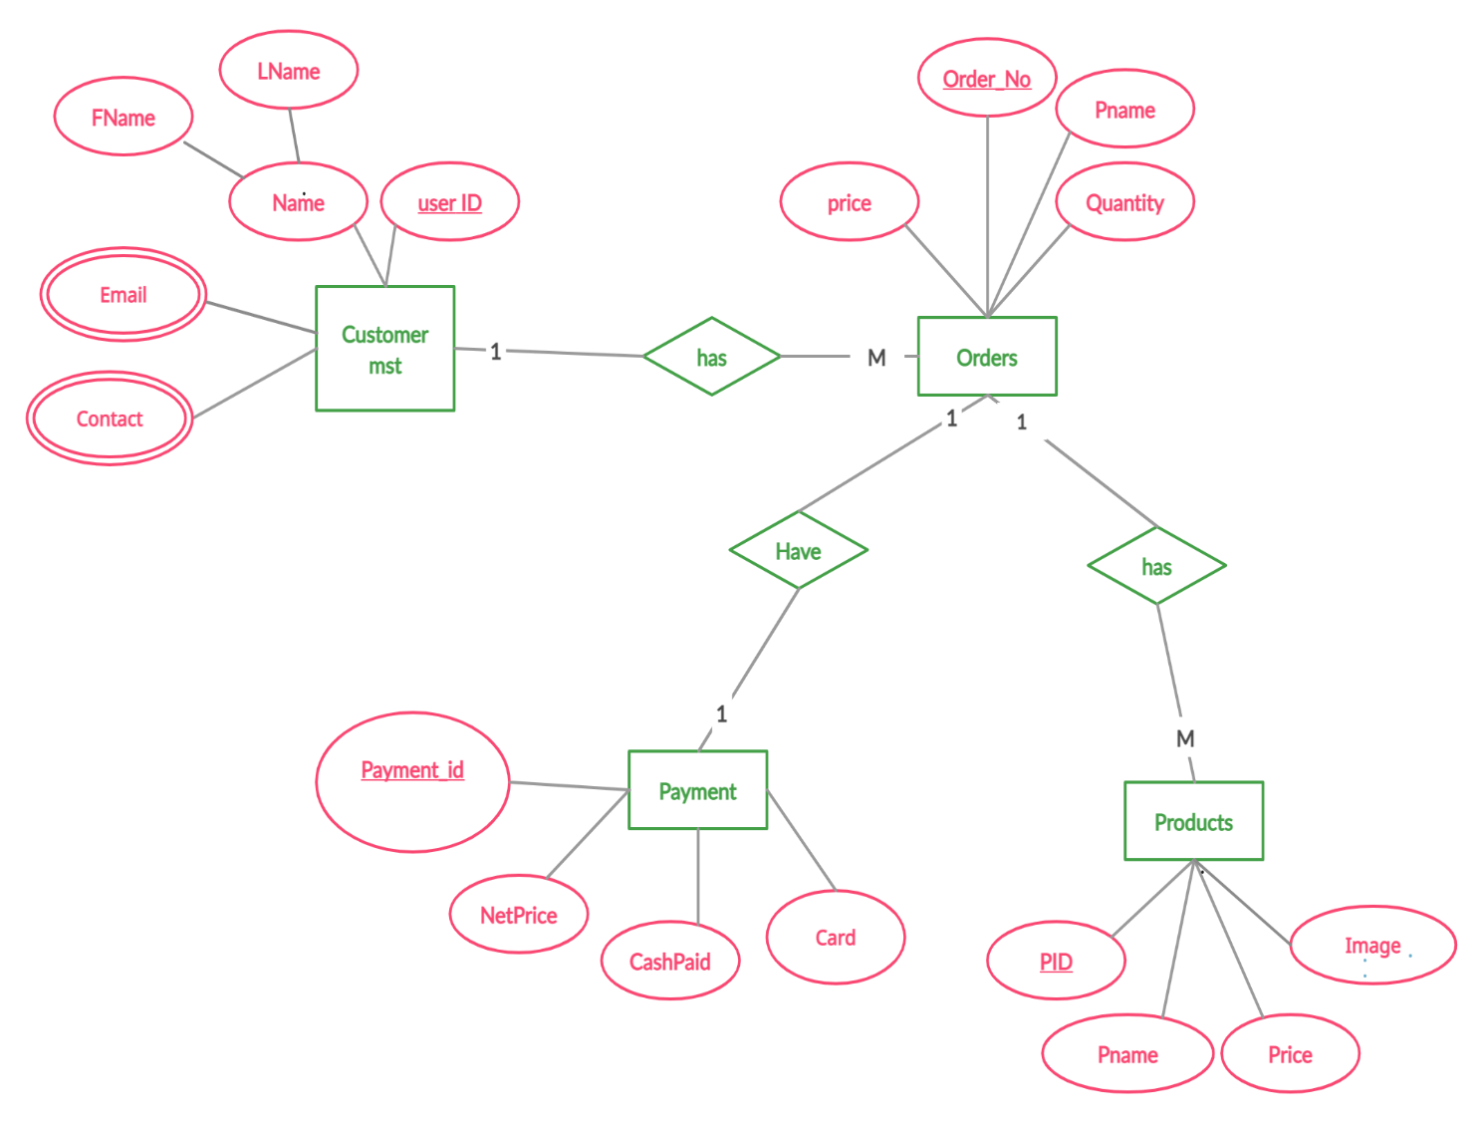

Fig 3.3.1: ER Diagram of Food ordering System.

### 3.3.2 Use–case Diagram

### 

A use case is a technique used in software development and system design to identify, clarify, and organize the requirements of a system or software application. It defines the interactions between users and the system, as well as the steps and conditions involved in completing a specific task or goal. Use cases help ensure that a system or software application meets the needs and expectations of its users, and they can also serve as a basis for testing and validation.

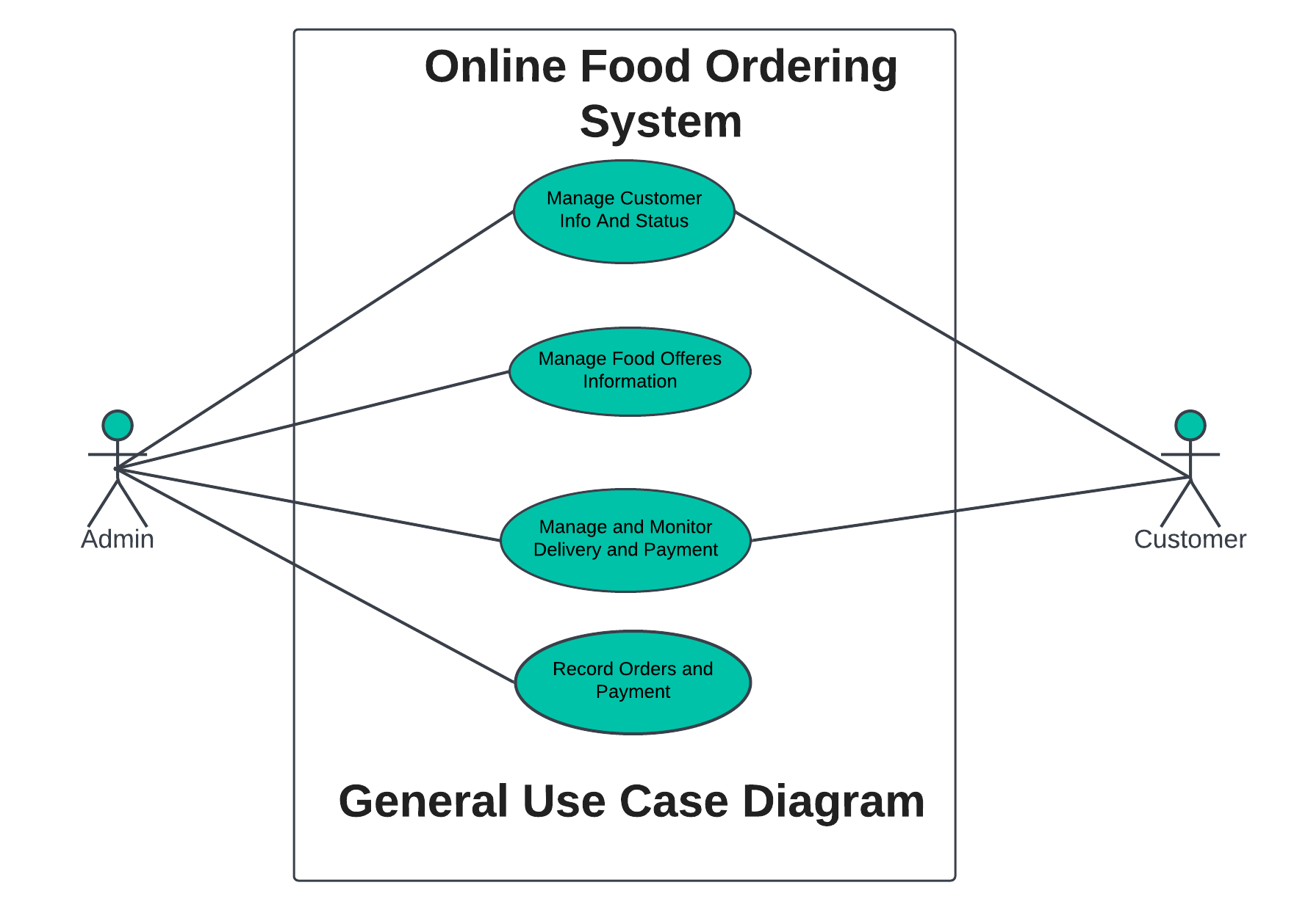

Fig 3.3.2: Use-case Diagram of Food Ordering System.

### 3.3.3 Process Modelling: Data Flow Diagram (DFD)

**Zero-level DFD (Context Diagram)**

A zero-level Data Flow Diagram (DFD) is the simplest type of DFD, which provides a high-level view of the system, without going into much detail. It shows the overall flow of data within a system and the external entities that interact with it. It typically consists of a single process symbol, which represents the entire system, and the external entities, which represent the sources and destinations of data. The zero-level DFD is often used as a starting point for developing more detailed DFDs and other system documentation.

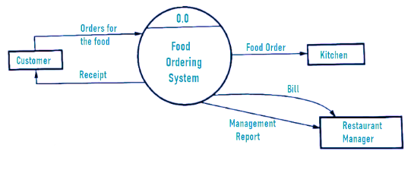

Fig 3.3.3:1 Zero level DFD of Food Ordering System.

**Level 1 Data Flow Diagram**

A Level 1 Data Flow Diagram (DFD) is a high-level representation of a system's processes and flows of data between them. It provides an overview of the system and its main processes, without going into the details of how each process works.

At Level 1, the system is typically divided into major processes or functions that represent the system's main capabilities. The data flows between these processes are also identified, showing how data is input, processed, and output by the system. The external entities that interact with the system are also represented, along with the data they input or receive from the system.

Overall, a Level 1 DFD provides a simple and clear overview of the system's main processes and data flows, making it an important tool for system analysts to understand the system's overall architecture and functionality.

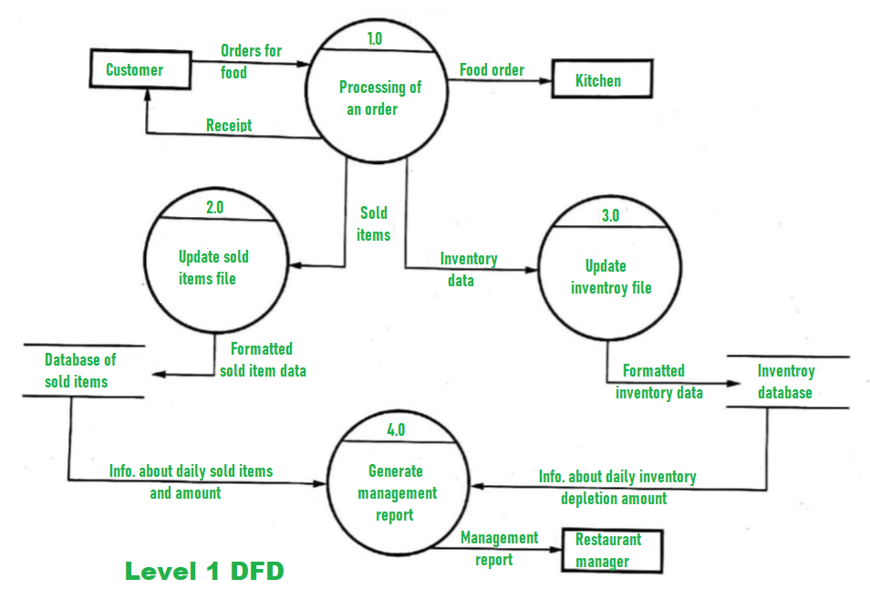

Fig 3.3.3:2 Level 1 DFD of Food Ordering System.

### 3.3.4 Gantt Chart

Fig 3.3.4: Gantt chart of Food Ordering System.

# **Chapter 4: System Design**

## 4.1 System Design

System design is a crucial phase in the development of a food ordering website. It involves defining the architecture, components, interfaces, and other characteristics of the system to ensure that it meets the needs of users and functions effectively and efficiently. The system design phase for a food ordering website focuses on creating detailed specifications that outline the structure and functionality of the system. This includes designing the database, creating a class diagram, activity diagram, flowchart, and implementing any necessary machine learning models to enhance the system's performance.

Database Design:

The database design for the food ordering website involves determining the structure and organization of the data. This includes identifying the entities, attributes, and relationships between them. The database design ensures efficient storage and retrieval of information related to customers, restaurants, food items, orders, payments, and other relevant entities.

Class Diagram:

A class diagram represents the static structure of the system by illustrating the classes, their attributes, and the relationships between them. In the context of a food ordering website, the class diagram will depict classes such as Customer, Restaurant, Food Item, Order, Payment, and their associations. It provides a high-level view of the system's structure and helps in understanding the relationships between different components.

Activity Diagram:

An activity diagram illustrates the flow of activities or processes within the system. In the case of a food ordering website, an activity diagram can depict the steps involved in placing an order, such as selecting food items, adding them to the cart, entering delivery details, and making a payment. It helps visualize the sequence of actions and decision points in the system.

By incorporating database design, class diagrams and activity diagrams, the system design phase ensures that the food ordering website is well-structured, functional, and capable of meeting the needs of users in a seamless manner.

# **Chapter 5.1: Appendices**

## 5.1.1 Screenshots

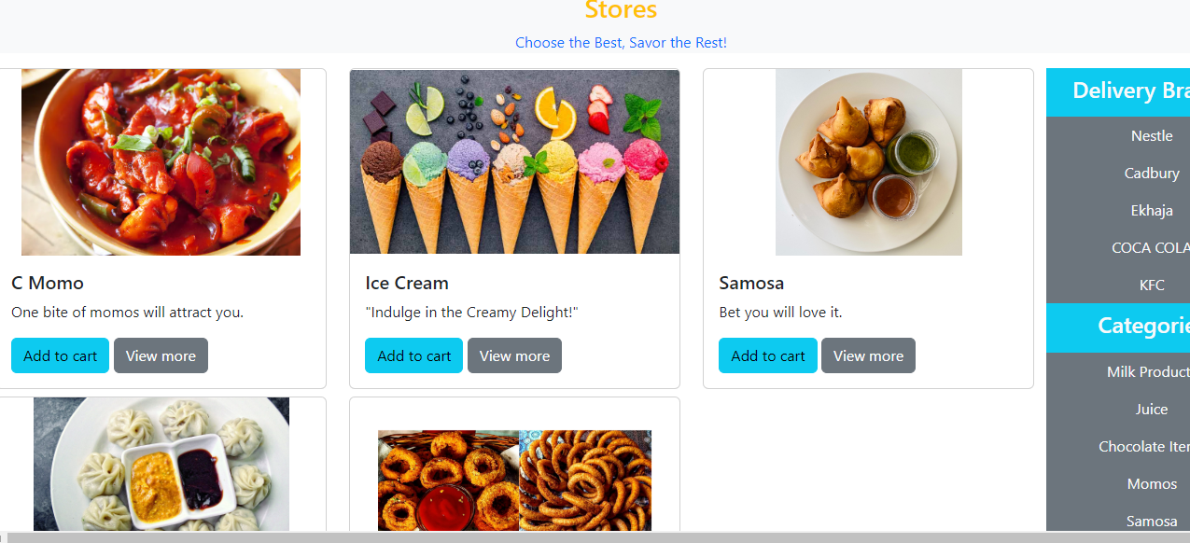

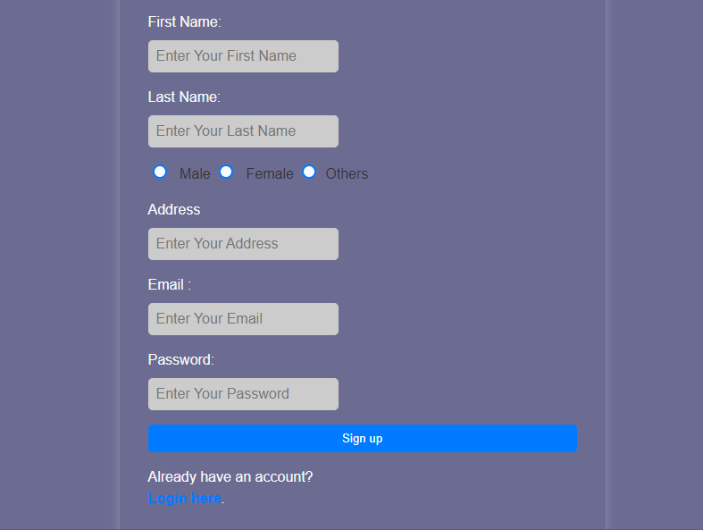

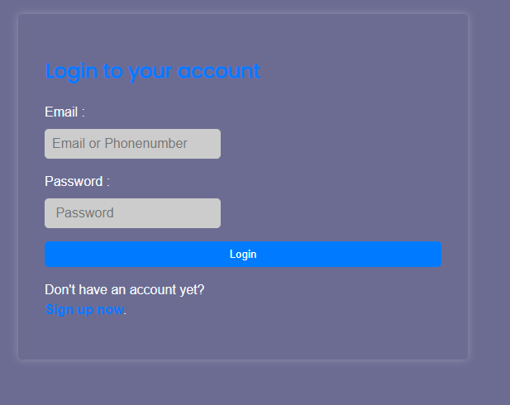

**Fig:Screenshots**

# **6. REFERENCES**

* “Foodmandu: Food Delivery Service in Kathmandu,” Foodmandu Main, https://foodmandu.com/ (accessed Jul. 1, 2023).
* “Khaanpin 24 hour online cloud kitchen - all time, on time - kathmandu & pokhara,” Khaanpin Online Cloud Kitchens - Kathmandu and Pokhara - 24 Hours Food, Liquor and Cakes - All Day All Night Pizza, Breakfast, Snacks and Dinner Delivery, https://khaanpin.com.np/en/ (accessed Jul. 1, 2023).